What is the Prim's Algorithm
Prim's Algorithm is a greedy algorithm that is used to find the minimum spanning tree from a graph. Prim's algorithm finds the subset of edges that includes every vertex of the graph such that the sum of the weights of the edges can be minimized. Prim's algorithm starts with the single node and explores all the adjacent nodes with all the connecting edges at every step.

How does the Prim's Algorithm work?
Step 1 - First, Initialize the minimum spanning tree with a vertex chosen at random.
Step 2 - Find all the edges that connect the tree to new vertices, find the minimum edge and add it to the tree.
Step 3 - Keep repeating step 2 until we get a minimum spanning tree.

Example of Prim's Algorithm
Consider the following graph as an example for which we need to find the Minimum Spanning Tree (MST).
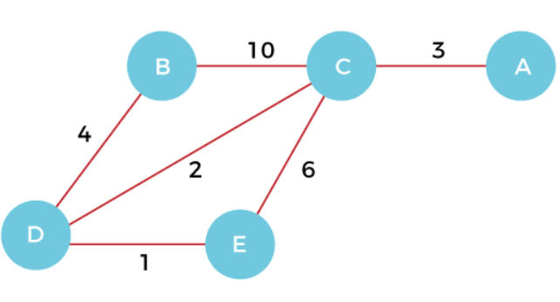

Step 1 - First, we have to choose a vertex from the above graph. Let's choose B.


Step 2 - Now, we have to choose and add the shortest edge from vertex B. There are two edges from vertex B that are B to C with weight 10 and edge B to D with weight 4. Among the edges, the edge BD has the minimum weight. So, add it to the MST.
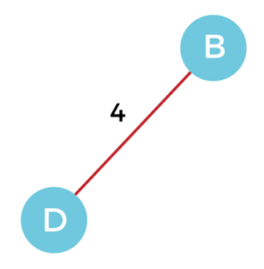

Step 3 - Now, again, choose the edge with the minimum weight among all the other edges. In this case, the edges DE and CD are such edges. Add them to MST and explore the adjacent of C, i.e., E and A. So, select the edge DE and add it to the MST.
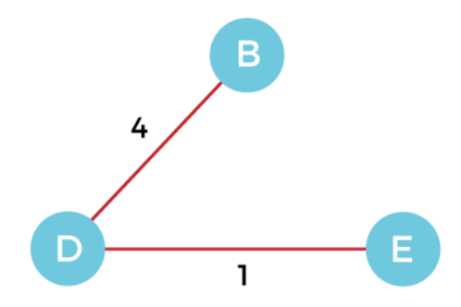

Step 4 - Now, select the edge CD, and add it to the MST.
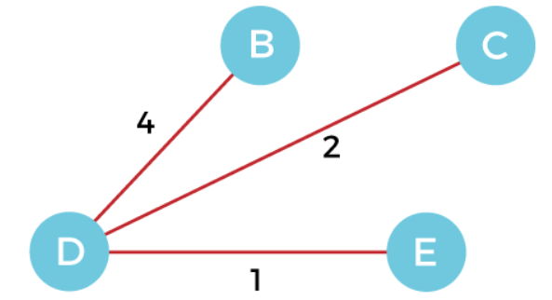

Step 5 - Now, choose the edge CA. Here, we cannot select the edge CE as it would create a cycle to the graph. So, choose the edge CA and add it to the MST.
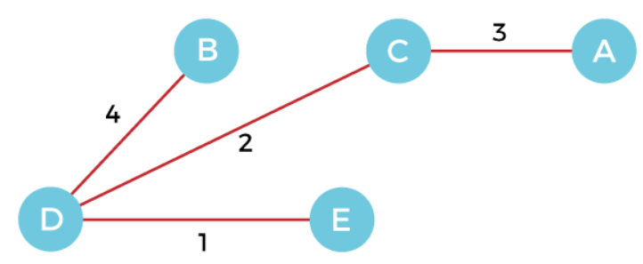

So, the graph produced in step 5 is the minimum spanning tree of the given graph. The cost of the MST is given below –
Cost of MST = 4 + 2 + 1 + 3 = 10 units.

Complexity of Prim's Algorithm

Data structure used for the minimum edge weights | Time Complexity
Adjacency matrix, linear searching |  | O(|V|²)
Adjacency list and binary heap |  | O(|E| log |V|)
Adjacency list and Fibonacci heap |  | O(|E|+ |V| log |V|)
Prim's algorithm can be simply implemented by using the adjacency matrix or adjacency list graph representation, and to add the edge with the minimum weight requires the linearly searching of an array of weights. It requires O(|V|²) running time. It can be improved further by using the implementation of heap to find the minimum weight edges in the inner loop of the algorithm.
The time complexity of the prim's algorithm is O(E logV) or O(V logV), where E is the number of edges, and V is the number of vertices.

Applications where Prim’s algorithm is generally used:
Prim’s Algorithm is used in various real-world applications where you need to find the Minimum Spanning Tree (MST) of a weighted graph. Here are some simple explanations of its uses:
Network Design: In telecommunications and computer networks, Prim’s Algorithm helps design efficient and cost-effective network layouts. It can be used to determine the optimal placement of communication cables or network connections while minimizing the total length or cost.
Circuit Board Design: When designing electronic circuit boards, you often want to minimize the length of connections between components to reduce interference and improve performance. Prim’s Algorithm can be employed to find the optimal arrangement of connections.
Transportation Planning: In transportation systems, such as road or railway networks, Prim’s Algorithm can help plan routes and connections. It ensures that you build new roads or railway tracks in a way that minimizes the total distance or cost.
Resource Management: When managing resources like pipelines for gas or water distribution, Prim’s Algorithm can determine the most efficient way to connect sources to destinations, minimizing the total length of pipelines while ensuring all areas are supplied.
Cluster Analysis: Prim’s Algorithm can be used in data analysis and clustering to find representative data points while minimizing the distance between them. This helps in identifying groups or clusters within datasets.
Image Processing: In image processing, it’s used for segmenting images into regions while minimizing the total “cut” cost. This can be applied in tasks like image segmentation and object recognition.
Robotics: In robotics, Prim’s Algorithm can be employed to plan paths for robots moving in a grid or on a map. It helps robots navigate efficiently while avoiding obstacles.
Spanning Tree Applications: Prim’s Algorithm, in general, is used in any application where you need to create a network or tree structure while minimizing some cost or distance measure. This could include tasks like designing electrical grids, connecting sensors in a sensor network, or creating a hierarchical structure in computer science.

Difference between Prims and Kruskal Algorithm
Prim’s Algorithm | Kruskal’s Algorithm
This algorithm begins to construct the shortest spanning tree from any vertex in the graph. | This algorithm begins to construct the shortest spanning tree from the vertex having the lowest weight in the graph.
To obtain the minimum distance, it traverses one node more than one time. | It crosses one node only one time.
Prim’s algorithm has a time complexity of O(V²), V being the number of vertices and can be improved up to O(E log V) using Fibonacci heaps. | Kruskal’s algorithm’s time complexity is O(E log V), V being the number of vertices.
Prim’s algorithm gives connected component as well as it works only on connected graph. | Kruskal’s algorithm can generate forest(disconnected components) at any instant as well as it can work on disconnected components
When it comes to dense graphs, the Prim’s algorithm runs faster. | When it comes to sparse graphs, Kruskal’s algorithm runs faster.
It generates the minimum spanning tree starting from the root vertex. | It generates the minimum spanning tree starting from the least weighted edge.
Applications of prim’s algorithm are Travelling Salesman Problem, Network for roads and Rail tracks connecting all the cities etc. | Applications of Kruskal algorithm are LAN connection, TV Network etc.
Prim’s algorithm prefer list data structures. | Kruskal’s algorithm prefer heap data structures.

